**CONTENTS**

**1. About……...................................................................................................... 2**

**2. Working OF VENDING MACHINE.................................................................. 2**

**(I) CODE …………………………........................................................................... 2**

**(ii) EXECUTING:............................................................................................. 4**

**About:**

A vending machine is an automated machine that provides items such as snacks, beverages, cigarettes and lottery tickets to consumers after cash, a credit card, or a specially designed card is inserted into the machine. The first modern vending machines were developed in England in the early 1880s and dispensed postcards. Vending machines exist in many countries, and in more recent times, specialized vending machines that provide fewer common products compared to traditional vending machine items have been created.

**Working OF VENDING MACHINE:**

Vending machines measure coins and read paper money. Each machine differs slightly, but in general, it identifies each coin with an electromagnetic field which measures thickness and diameter. Dollar bills are scanned with a laser, which transmits to a small computer that deciphers each denomination.

**CODE:**

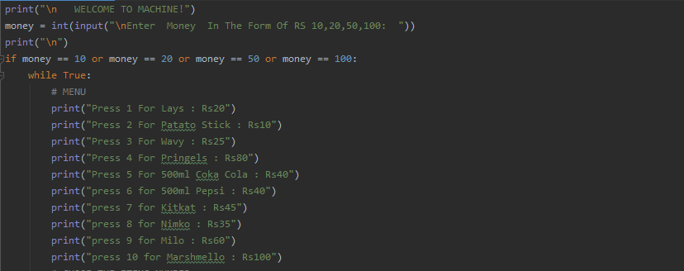(1.0)

As you can see figure 1.0 is starting of our code. In which we can see the Menu of our program .We execute our code by pressing Shift+Tab+F10 or right and select the run command from options.

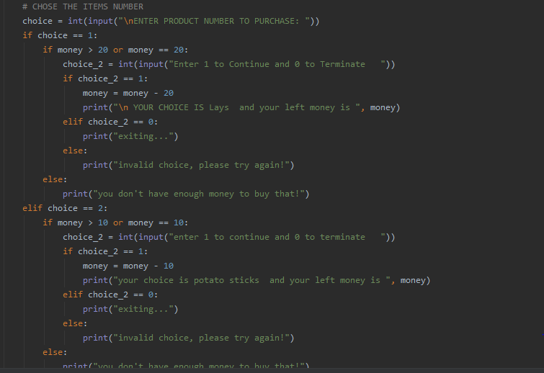

(1.1)

Figure 1.1 shows the code of choice 1 element of our program . There are 10 choice element in our program.

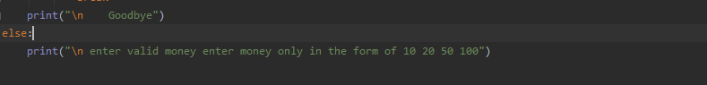

(1.2)

Figure 1.2 show the end of our code .

**EXECUTING:**

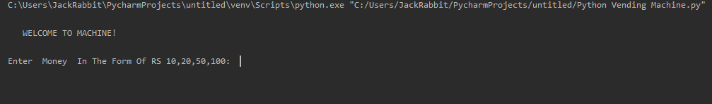(2.0)

Figure 2.0 show the screen of pycharm which it will show when we start execting the program. We start executing program by pressing Shift+Tab+F10 or right and select the run command from options.

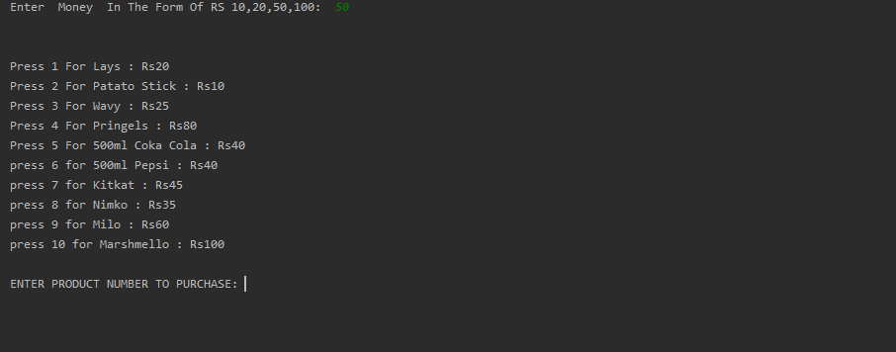

(2.1)

Figure 2.1 show the screen of pycharm when we entre any amount of money. We can only entre money only in the form of 10,20,50,100 otherwise it will show Message “Entre valid money in the form of 10, 20, 50, 100”.

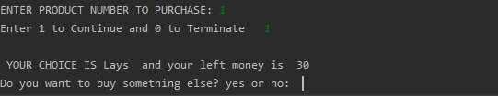

(2.2)

Figure 2.2 show the screen of pycharm when we select our product of our choise to buy by typing its number.

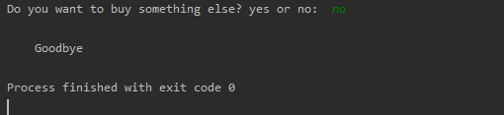

(2.3)

Figure 2.3 show the screen of pycharm with Message “Goodbye” when we complete our purchase and our program is terminated.

THE END

************************************************